The Lightweight IBM Cloud Garage Method for Data Science

Architectural Decisions Document Template for COVID-19 Predictions

# Architectural Components Overview

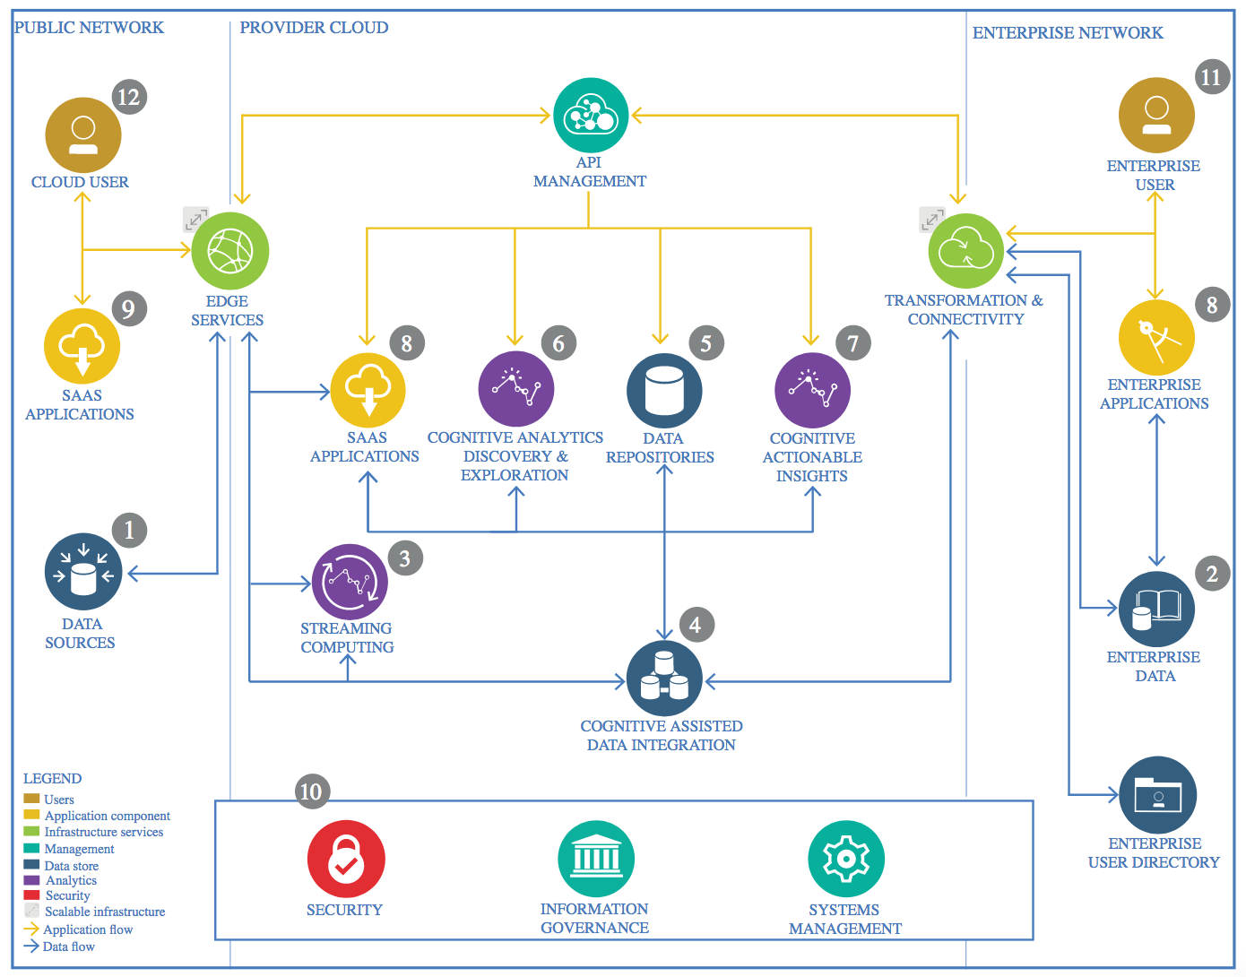

IBM Data and Analytics Reference Architecture. Source: IBM Corporation

## Data Source

### Technology Choice

Please describe what technology you have defined here. Please justify below, why. In case this component is not needed justify below.

**John Hopkins University time series COVID19 Data Set from Github CSV Files**

### Justification

Please justify your technology choices here.

## Enterprise Data

### Technology Choice

Please describe what technology you have defined here. Please justify below, why. In case this component is not needed justify below.

* **IBM Watson Studio Jupyter Notebooks, scikit-learn, pandas**

### Justification

Please justify your technology choices here.

## Streaming analytics

### Technology Choice

Please describe what technology you have defined here. Please justify below, why. In case this component is not needed justify below.

### Justification

Please justify your technology choices here.

## Data Integration

### Technology Choice

Please describe what technology you have defined here. Please justify below, why. In case this component is not needed justify below.

* **IBM Watson Studio Jupyter Notebooks, scikit-learn, pandas**

### Justification

Please justify your technology choices here.

## Data Repository

### Technology Choice

Please describe what technology you have defined here. Please justify below, why. In case this component is not needed justify below.

**IBM Watson Studio**

### Justification

Please justify your technology choices here.

## Discovery and Exploration

### Technology Choice

Please describe what technology you have defined here. Please justify below, why. In case this component is not needed justify below.

**Jupyter notebook**

### Justification

Please justify your technology choices here.

## Actionable Insights :

## **Predict COVID-19 Confirmed cases and display graphs by World, US**

### Technology Choice

**Jupyter Notebook**

### Justification

Please justify your technology choices here.

## Applications / Data Products

### Technology Choice

Jupiter Notebook, PowerPoint

### Justification

Please justify your technology choices here.

## Security, Information Governance and Systems Management

### Technology Choice

Please describe what technology you have defined here. Please justify below, why. In case this component is not needed justify below.

### Justification

Please justify your technology choices here.